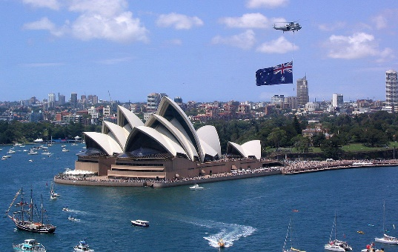
AUSTRALIA: Fill in!

The capital of Australia is ____________________. Australia's population is about _________________.
There are 6 states and 2 territories: ___________________________
____________________________________________________________________________________.
The three biggest cities are _____________________________________________________________.
Australia is about as big as the __________ without _____________________________.
The official language is _____________________, and the Australian currency is the ______________________________ .
Queen Elizabeth II. is the ______________ _____ _____________.

The first people of Australia were the ______________________. They have lived in Australia for more than _______________ years.
Settlers from Europe began to come to Australia in the 18th ______________. Since then, the Aborigines have lost most of their _______________ and their culture. Today only about _______________________ of the population are Aborigines. They have many problems, for example ___________________________, __________________________ and __________________________.

In Australia, the distances are very long. So there is the “____________________________________ “: The doctors fly to their patients.
And there are the “_______________________________________”: Children talk to their teachers over the _______________ or radio, and they are taught by their parents.
The country is so large that there are not enough railways in the outback. So there are "roadtrains“:
These are ________________ with many trailers - like trains.

There are over 7000 beautiful ____________________ in Australia – and Australians love swimming, surfing, diving and everything that has to do with water. There is only one problem: Many of Australia's most dangerous animals, like _________________ and ______________________ live in the water!

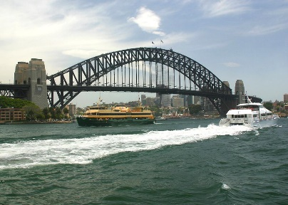
Sydney
It is the largest, oldest, and most beautiful city. The most famous building is the ______________ _____________. It is in the harbour and it looks like a huge ________________ ____________. People can climb the Harbour _______________.

The Great Barrier Reef
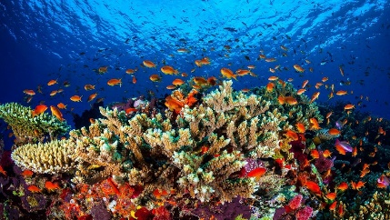
It is the largest coral _________ in the world. There are hundreds of tropical _________________ with wonderful beaches. The ____________________
is very dangerous for the reef – The corals could die.

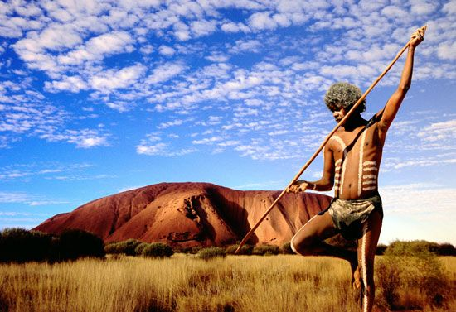
Ayers Rock
It is __________ metres high red rock in the middle of the continent. Ayers Rock is called _________________ by the Aborigines. For them, it is a ______________ place and they don't like it when tourists climb to the top. It is in a National Park.

Kakadu National Park
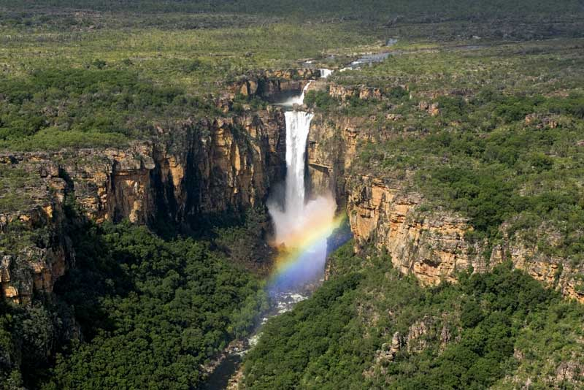
It is in the tropical north. You can see many different ______________________ there, like crocodiles or birds. You can swim in waterfalls or pools, and there are very old _____________ __________________ there.

